**Best SEO Agency in Dehradun-mhttps://www.10xdigital.ae/services/seo-dubai/**

**GROWTH – DRIVEN**

**BEST SEO AGENCY IN DUBAI**

**BAKI SAB KUCH SAME HOGA BANNER IMAGES KA BS COLUR CHANGE KARENA**

**Imse se second wala images use kar lena -** [**https://www.incredibleindia.gov.in/en/uttarakhand/dehradun**](https://www.incredibleindia.gov.in/en/uttarakhand/dehradun)

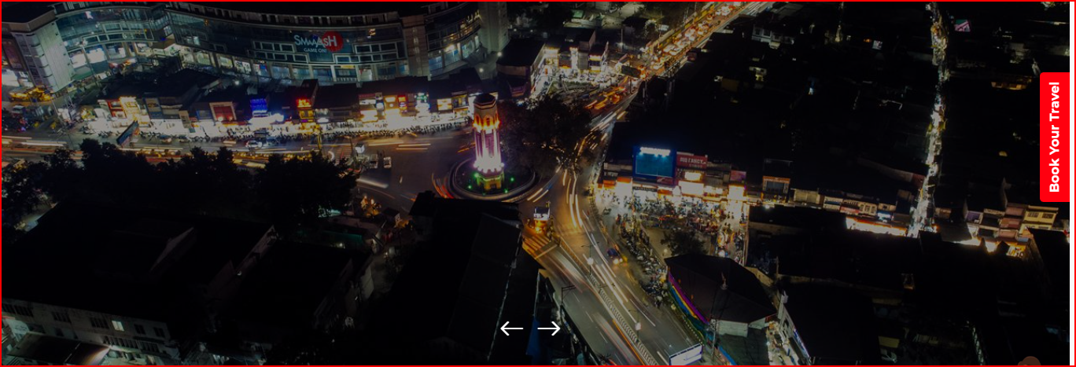



If you are looking for the most trusted and performance-driven **SEO Agency in Dehradun**, RS Organisation is your ideal partner. As a **top SEO company in Dehradun**, we specialize in crafting strategies that increase rankings, attract organic traffic, and generate real business growth. With proven expertise in **SEO services in Dehradun**, we ensure long-term success by combining technical optimization, engaging content, and powerful link-building strategies. Whether you are a startup or an established business, our tailored SEO solutions will help you scale and outperform your competition.

**Professional SEO Services in Dehradun**

At RS Organisation, we offer **professional SEO services in Dehradun** designed to enhance visibility, credibility, and sales. Our SEO experts focus on improving your website’s ranking on search engines through ethical practices like **organic SEO, on-page optimization, off-page SEO, and local SEO strategies**. With us, your business gains more exposure, sustainable traffic, and measurable results. We don’t just promise rankings—we deliver consistent growth by aligning our SEO strategies with your business goals. Our services are designed to convert visitors into loyal customers while ensuring long-term brand authority in the Dehradun market.



<https://www.10xdigital.ae/services/seo-dubai/>

**Our SEO Services**

**1. Organic SEO Process**

Our **organic SEO process** focuses on keyword research, on-page improvements, and technical optimization. We create strategies that align with Google’s guidelines, ensuring long-term growth without shortcuts. Organic SEO provides sustainable rankings and high-quality traffic.

**2. Business Changing Results**

SEO is not just about rankings; it’s about driving results that impact your bottom line. At RS Organisation, we deliver **business-changing SEO results** by generating leads, increasing conversions, and improving overall revenue through customized strategies.

**3. Dedicated SEO Team**

We have a **dedicated SEO team** that works exclusively on your project. Our experts bring years of experience, creativity, and technical knowledge to deliver the best results for your business in Dehradun’s competitive digital market.

**4. Taking Responsibility**

At RS Organisation, we believe in accountability. From keyword planning to execution, we take full responsibility for your campaign’s performance. Our strategies are transparent, measurable, and designed to achieve your business objectives efficiently.

**5. Off-Page SEO**

We specialize in powerful **off-page SEO** techniques, including link building, content distribution, guest posting, and brand mentions. This increases your website’s authority, boosts search rankings, and establishes your brand as a trusted name in your industry.

**6. Monthly Reporting**

Transparency is our core strength. With **monthly reporting**, you’ll receive clear insights into traffic, keyword rankings, and campaign progress. We ensure you’re always updated on results and ROI from our SEO efforts in Dehradun.



**Why Choose RS Organisation for Your SEO Services?**

**RS Organisation is a Noida-based SEO company** delivering high-quality SEO services across India, including Dehradun. What sets us apart is our commitment to ethical practices, transparency, and business-focused strategies.

We focus on:

* **Proven Track Record** – Years of experience delivering measurable SEO results.
* **Customized Strategies** – Every business is unique, so we design personalized SEO campaigns.
* **Comprehensive Services** – From on-page to **local SEO company in Dehradun**, we cover all aspects.
* **Advanced Tools & Techniques** – We use the latest SEO tools for precise analysis and optimization.
* **Expert Team** – A team of SEO specialists ensuring consistent monitoring and performance improvements.
* **Sustainable Growth** – We deliver SEO services that not only rank but also sustain long-term growth.

At RS Organisation, our mission is simple: to help businesses in Dehradun dominate the digital space with trusted SEO services. If you want higher visibility, more customers, and greater ROI, partner with the best **SEO Agency in Dehradun** today.